MOVAVI Screen Capture Studio 9

Screen Capture and Video Editing $59.95
https://www.movavi.com/screen-recorder/personal/

Below is a brief description of how to use MOVAVI to record a PowerPoint presentation; use the edit function once a presentation is recorded; then convert it to a video.

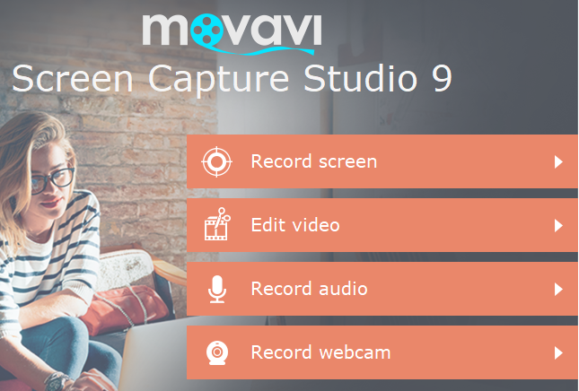
Open MOVAVI: The opening screen will show the selections shown below. Click on “Record screen” to open the setup tool for recording a PPT presentation. (It takes a while to load.) The opening screen will also allow you to select a useful tutorial. “Capture your desktop” is a helpful tutorial for capturing a PowerPoint Session—similar to the instructions below. Close the tutorials screen.

The setup tool shown below will be displayed. These are one time actions and are the settings recommended.
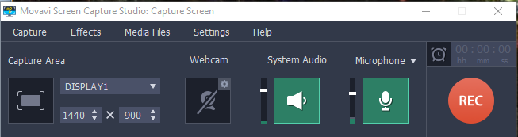
1. Set the “Capture Area” to DISPLAY1 by clicking on the down arrow to expose various Capture Area options. DISPLAY1 will allow the full screen to be captured. The “System Audio” and “Microphone” buttons should be green in color, indicating they are active. If not, click on each. The “Webcam” should not be active (green). The microphone level can be set by sliding the white bar up or down.

2. Click on “Settings”, then “Preferences”. Under the “General” tab, remove the check mark in “Capture separate streams”. (It must be unchecked or the editing function will not work correctly.) The other default settings can be left as they are found.

Open the PPT presentation you wish to record in “Show mode”. When ready to record, click on the Record button. There will be a 3 second count down before the recording actually starts. You can use the F10 key to pause or resume the recording, as well as stop the recording.

After the recording is been stopped, click “Open in Editor” to edit the recording. (Patience—it may take a while)
To delete a pause, an “umm”, or a vocal error:
- Click within the video area and drag the orange cursor to the starting point for the edit. (See example below)
- Click scissors
- Place the orange cursor on the end edit point
- Click scissors again
- Left click inside the area to be deleted. The area to be removed will be outlined in yellow.
- Press the delete key or click on the garbage can to delete the video and audio for that selection.
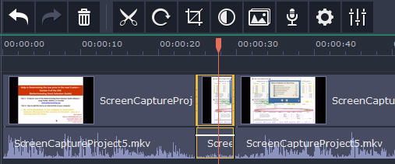
(In this example about 5 seconds of silence will be deleted—both audio and video—between the 25 and 30 seconds indicators. Note the yellow outline.)

Use the “Undo” arrow at the upper right to restore any unwanted changes.

Once all editing is completed
- Click “Export” button. Select “MP4 (MPEG-4)” (The MPEG-4 format will create the smallest video file.)
- Name the project
- Choose where to save the project
- Set Quality to “Good” (Note the “File size:” will change as the following steps are completed.)
- Click on “Advanced” (The following are suggested settings.)
- Set Resolution to 640X480 (This setting is critical in balancing the quality and size of the finished video. Experimentation is suggested.)
- Set FPS (Frames per Second) to 8
- Set Sample rate: to 8000 and Channels: to Mono
- Click OK
- Click “Start” to convert the edited presentation to the video format MP-4. (This will take a while)
Congratulations, you now have a video which can be uploaded to the internet.

