Review the Stocks in Your Portfolio Conveniently—Regularly
Note: The link to this tool is at the end of this article

We all recognize the need to keep an eye on each stock held in a portfolio or a watch list. Some clubs have a form just for that purpose and some leave it up to the individual who is following the company. In either case, it’s an important job. This article describes an Internet tool on BigCharts.com that augments the stock watcher information and makes it easy to see important information—and can be set up to be a double key click away. I highly recommend it be set up as an icon on your desktop. Visibility allows it to be seen and reminds one to use it.

How does it help in making decisions? By making a few comparisons a decision can become obvious. See the figure below, using Apple as an example. Once on BigCharts.com type in the ticker symbol of the company to be analysed. This is a ten year chart, which allows full market cycles to be seen. There are three sections.

The first section is a comparison of the company price to the S&P 500 index fund—heavy line is the company price and the light line the S&P 500. Is the company price increasing at a greater rate than the market average? Also compare the volatility of the company price to the index fund. Be aware companies are likely to be more volatile than an index since the index covers multiple companies and the action of single, or a few companies, has a smaller effect on the total. Comparing one company to a peer company is a good test as well.
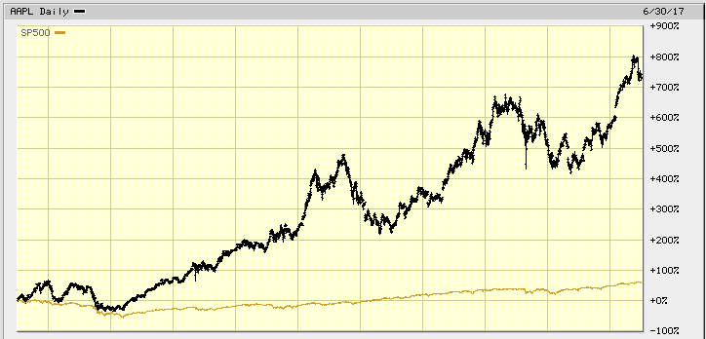

The second section shows the P/E of the company. Use the chart to determine the normal P/E and note where the current P/E is in relation to that normal value. What is the volatility? A P/E above the normal range is not likely sustainable and if above the market average the same may be true. The long term average of the S&P 500 P/E is in the 17-18 range. Compare that to the current P/E of the company. The chart shows the P/E of AAPL in 2008 was very high and fluctuating greatly. The price languished during that time as well. The recent average is much lower and stable indicating though the price was rising, EPS also rose in concert, averaging around 15, a reasonable P/E.
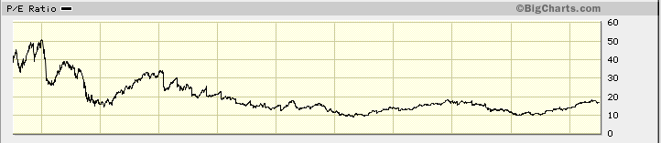

The third section shows the EPS for the company each quarter. Is it rising, and rising steadily. Compare EPS to the price and P/E and observe the relationship to each.
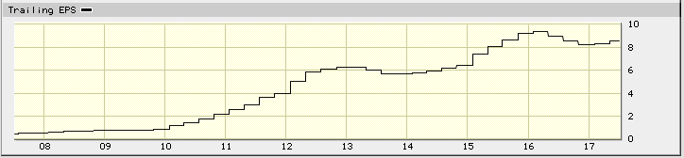

See the next page, below, for installation instructions.
To gain access to this tool go to www.bob-adams.net/technical-tools and download this article. Instructions on placing the tool on your computer are available there. The BigChart address for this chart is too long to type in. By downloading this article from my website it becomes a copy and paste exercise. Instructions are contained in the downloadable article.
--Bob Adams

Place the icon below on your desktop for easy access and use. NOTE: If you receive warnings that this is a dangerous act if you don’t know the source of the file don’t be concerned. The icon is safe to copy to your desktop. (Click on the icon below and copy it (Ctrl+C). Click on any blank area of your desktop screen and paste it (Ctrl+V)). Double click on the icon to go to BigCharts.com. Type in a new ticker symbol for the company you want to follow.

Or, if you prefer, copy and paste the link below into your browser and save it as a Favorite.

http://bigcharts.marketwatch.com/advchart/frames/frames.asp?show=&insttype=Stock&symb=aapl&time=13&startdate=1%2F4%2F1999&enddate=6%2F9%2F2017&freq=1&compidx=SP500&comptemptext=&comp=none&ma=0&maval=9&uf=0&lf=16777216&lf2=67108864&lf3=0&type=2&style=320&size=3&timeFrameToggle=true&compareToToggle=true&indicatorsToggle=true&chartStyleToggle=true&state=15

--Bob Adams

