Build Your Nest Egg for Your Future
(An Example)
--Bob Adams

Sixty years ago I was in the Marine Corps and overseas. Not much to spend money on, so it became a habit to send my monthly paycheck to my Fiancée, now my wife Cris of 64 years. (I got one of the really good ones.) I had no idea of the importance of saving for retirement, etc., but it was logical to save so it would be available if needed. When I returned home and we were married, there was a nice little pile of money in the bank. We knew nothing about investing so it languished in a Savings Account for several years, until we bought a home.

After a few more years the little pile of money then allowed us to buy another home and turn the first one into a rental. That continued until we had seven rentals. That little pile of money started it all. Then, my best friend, and Better Investing, taught me how to invest in the stock market. As a result, we now have a plan to help in the retirement all the way through our great grandchildren.

How is this all possible? Though we didn’t understand the importance of it at the time, we started early. That’s the point young people need to understand. So, get crackin’—regardless of your age. If young, how much should be saved? 15% of the big number at the top of your pay stub, and set it up for automatic transfer. If your company offers a 401(k) transfer it to that account. If not, set up a Roth IRA and deposit it there.

The next question: How to invest it. That’s easy too—an Index Fund. Stay with the best known indices, like the S&P500, Dow Jones Industrial Average, Total Market, etc. The NASDAQ 100 is a good one too—outperforming other indices during the past 3, 5, and 10 years. If your 401(k) doesn’t include any index funds, ask they be added.
Once set up, relax. There is no need to watch it like a hawk. There is a need to remain invested for the long term.

Regardless of whether you’re just starting out or “older”, here’s some guidelines on where you should be at various ages. Fidelity Investments recommends the following benchmarks:
Age 45 – 4 times gross salary
Age 55 – 7 times gross salary
Age 65 – 10 times gross salary
These are rough estimates of where you need to be at each of the ages. But there is a better way. The link below will take you to the Fidelity site and a tool which allows you to see where you are, and what needs to be done to improve your future retirement status, if anything.
https://communications.fidelity.com/pi/2015/retirement/

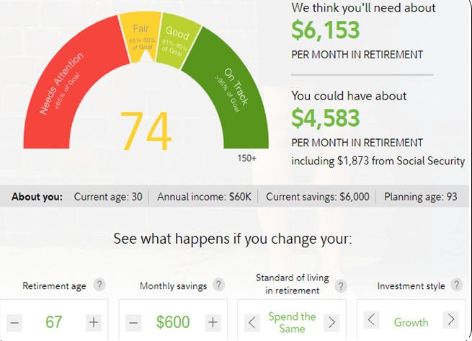
The figure shows the tool, and that the example is signifying this person needs to increase the savings rate or delay retiring--$6,153 is expected to be required in retirement but is projection is to have only $4,583 per month. Note the retirement age, monthly savings, standard of living expectation, and investment style are all adjustable. Change the variables to change the outcome, but be realistic.
Also note the total includes an expected Social Security monthly payment of $1,873.

