Technical Tools for the Fundamental Investor
When to buy and when to sell

The Stock Selection Guide is a great tool for determining what to buy, but is somewhat lacking in the timing of a buy, and seriously lacking in determining when to sell. This tool helps in both decisions, utilizing four technical indicators to suggest if the timing is right. I won’t go into details about each indicator, only how to interpret them. To learn more about each of these indicators, use the links at the end of these instructions. The example investment is the QQQ ETF. Type in a new ticker symbol to see the company of your choice and click Update. The period of the example data below is for six months. It will be changed to three months for better clarity during actual use, but can be changed. – Open the tool, scroll down to the “Charts Attributes” area and change 3 months to 6 months. Click Update. A word of caution: this tool mainly designed to show possible buy and sell signals for index funds not individual companies. (Individual companies may show more buy and sell signals than are useful.) Index funds contain many companies and are normally less volatile.

- The graph below shows the price in relation to two moving averages (EMAs). When the fast moving average (blue line) crosses above the slow moving average (red line), it is an indication of a possible buy. If the reverse is true, it is an indication of a possible sell. Look at the other indicators before making a decision however. The heavy black line represents the daily price.

The Volume shown at the bottom is of some interest, but doesn’t contribute to the decision making process.
Enter a new ticker symbol and click “Update” to see a new index/company. Click on “Inspect” to add vertical and horizontal lines to more easily see how the 4 tools relate to each other.

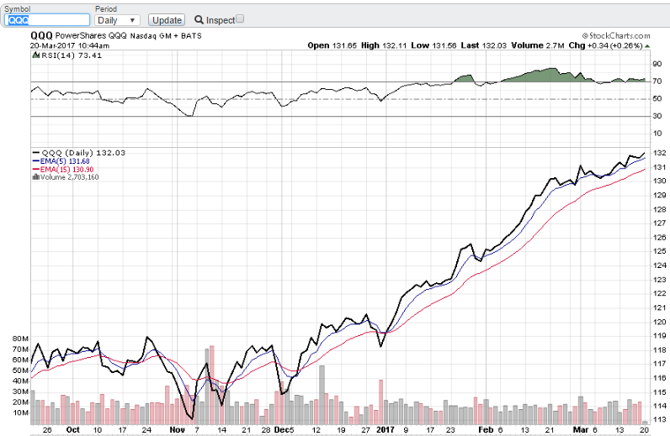
An over-bought indication. Watch the other indicators closely

A strong sell indication

A second possible time to sell

An early possible time to sell

Price
A possible time to buy

A second possible time to sell

An early possible time to sell

Fast Moving Average

Slow Moving Average

- The MACD (pronounced Mac-Dee) is used to confirm any buy or sell signal given when EMA signals cross each other. The blue columns indicate the strength of the MACD signal.
MACD confirms a possible sell
MACD suggests a sell
MACD Lne

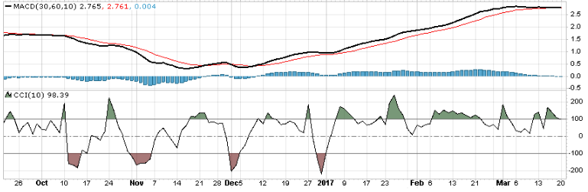
Zero line

CCI confirms a buy signal

MACD confirms a buy signal

CCI confirms a sell signal

MACD Histogram shows strength of buy or sell signal confirms a sell
MACD Signal Line

Notice in this example there are two EMA signals of a sell on the chart but the MACD confirmation for the first is quite weak. (Blue MACD Histogram columns are hovering around zero.) At the very least, we should watch this investment very closely with a sell bias. When the second EMA signal to sell occurs, prior to the precipitous drop, the MACD is confirming a sell—a strong sell.

The early sell EMA indicator is only weakly confirmed by the MACD and would possibly result in no action. The second EMA sell signal is definitely confirmed by the MACD and clearly indicates a sell. The blue columns indicate the distance between the red and black lines of the MACD—thus the strength of the change in direction.

When should we buy? The EMA signals a buy indicated on the chart as “A possible time to buy”, confirmed by the MACD.

- The RSI (at the top of the chart—see above) and CCI merely serve to confirm the strength of what the EMA and MACD are indicating. Both are momentum indicators of the price. The stronger the indication the stronger the price momentum. Above the CCI zero line and above the RSI 50 line indicates strength and below the line indicates price weakness. Use both as a general confirmation of the other tools described here.

This link will open the tool: (This link must be saved to your computer—see instructions below.)
http://schrts.co/hJN0b8

This tool cannot be saved once opened on your computer. It is necessary to save the URL—either as a “Favorite” in your browser or as an icon on your desktop. How this is done depends on your computer operating system.
Saving it as a Favorite on your browser often means clicking on the Star normally found at the top of your browser screen—usually on the right side—then locating the URL on the list of Favorites you have previously saved. Click on the >> double chevron, at the upper right to open the list. Scroll until the URL is found—usually the last URL on the list. The name will be similar to the link to the tool used above. The link can be renamed to your preference.

Some browsers will allow dragging and dropping the URL to your desktop. (Click on the URL. Once the tool is open, drag the URL displayed on the web browser to your desktop) If dragging and dropping is allowed, the URL will appear as an icon, which will allow future access to the tool. If not, right click on an empty space on your desktop screen, click “New”, then “Shortcut”. In the box titled “Type the location of the item:” type this URL http://schrts.co/hJN0b8 in the box. Click next. The icon can be used to access the tool in the future. To analyze other companies/funds change the ticker symbol by typing a new ticker symbol in the “Symbol” box and click “Update”.

Some extra reading--To learn more about these tools use the links below:
EMA Exponential Moving Average:
http://stockcharts.com/school/doku.php?id=chart_school:technical_indicators:moving_averages
MACD Moving Average Convergence Divergence:
http://stockcharts.com/school/doku.php?id=chart_school:technical_indicators:moving_average_convergence_divergence_macd
CCI Commodity Chanel Index:
http://stockcharts.com/school/doku.php?id=chart_school:technical_indicators:commodity_channel_index_cci
RSI Relative Strength Indicator:
http://stockcharts.com/school/doku.php?st=rsi&id=chart_school:technical_indicators:relative_strength_index_rsi

